# Assignment Energy week

1. How many of the canal boats currently in use are diesel/fossil fuel driven and how  
   many boats are electrical driven?

In 2020 there were 550 canal boats in Amsterdam, owned by multiple companies. According to Reuters (2020), 75% of these boats (412 boats) are electrical driven. We suppose that the rest of the boats is fossil fuel driven.

1. Are there peak times for the canal boats?

There are certain peak times of the canal boats in Amsterdam (Grachtenmonitor, 2022). In the graph below, the average amount of boats per hour on a day is visualized.

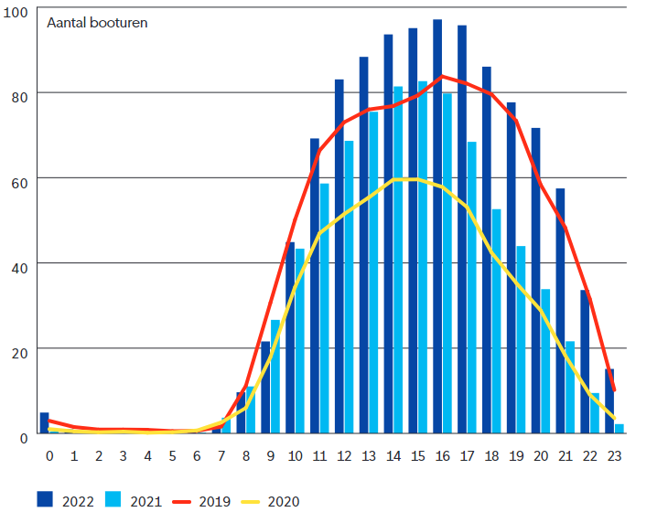

In the graph below, the weekly rhytm of canal boats in Amsterdam can be seen.

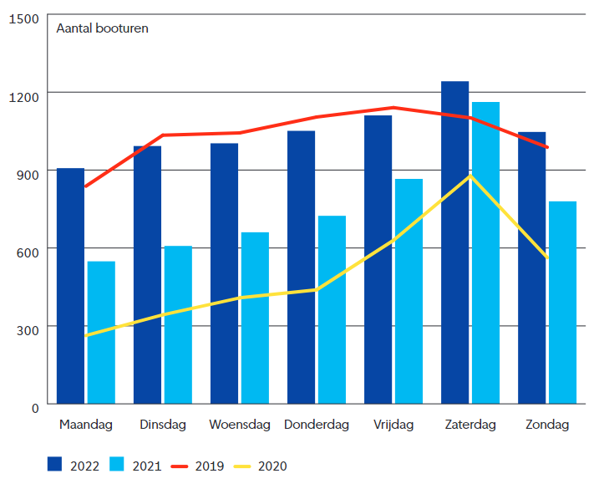

In the table below, the passages per hour of the day on certain locations in Amsterdam can be seen. It is clear that there are some very busy spots at certain times.

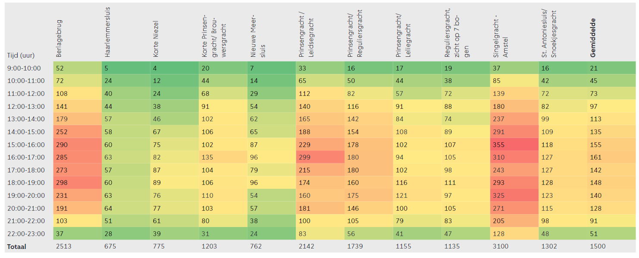

1. Try to compare the energy use of the canal boats to some other activity in the city.  
   Use canal boats more or less energy in relation to their carbon footprint compared to  
   these other activities?

Overal both energy use and CO2 emissions of the canal boats is higher both per individual bout compared to an individual eletric bus as wel as the totals, however there are only 44 electric busses where as there are 412 electric canal boats and 138 diesel ones.

|  |  |  |  |  |  |  |
| --- | --- | --- | --- | --- | --- | --- |
| Engine type | Power (kWh) | Hours in use/day | Energy use/year (kWh) | Footprint grey  (kg CO2/year) | Footprint windpower  (kg CO2/year) | Footprint solar  (kg CO2/year) |
| Electric | 26 | 10 | 39.098.800 | 14.466.556 | Upper limit | Upper limit |
| 1.329.359 | 1.172.964 |
| Lower limit | Lower limit |
| 312.790 | 508.284 |

<https://www.wattisduurzaam.nl/35498/energie-opwekken/zonne-energie/europese-zonnepanelen-nog-iets-beter-voor-klimaat-dan-chinese/#:~:text=De%20wetenschappers%20aan%20het%20Duitse,n%20800%20gram%20CO2%20uit>.

<https://decorrespondent.nl/4256/factcheck-windmolens-kosten-meer-energie-dan-ze-opleveren-en-helpen-het-klimaat-niet/c2faef7a-df3a-0150-1a71-204f4ea80f44#:~:text=Daaruit%20blijkt%20dat%20de%20gemiddelde,gemiddeld%20900%20gram%20per%20kWh>.

|  |  |  |  |  |
| --- | --- | --- | --- | --- |
| Engine type | Average litres/hour | Hours in use/day | Energy use/year | Footprint  (kg CO2/year) |
| Diesel | 4 | 10 | 2.014.800 L  20.148.000 kWh | 5.250.568,8 |

|  |  |  |  |  |
| --- | --- | --- | --- | --- |
| Bus | Energy use/year  (kWh) | Footprint grey  (kg CO2/year) | Footprint windpower  (kg CO2/year) | Footprint solar power  (kg CO2/year) |
| Electric | 3.300.000 | 1.834.800 | Upper limit | Upper limit |
| 112.200 | 26.400 |
| Lower limit | Lower limit |
| 99.000 | 42.900 |

https://waterstofgate.nl/Praktijk/Businesscase-Bussen-verbruik/Businesscase-Bussen-CO2-uitstoot/#:~:text=Zijn%20er%20zorgen%20over%20de,en%20verbruikt%2075.000%20kWh%20elektriciteit.

1. Would you consider it economically feasible?

Converting a canal boat with a diesel engine to an electric engine is expensive. For a typical 23m (75ft.) tourist boat, this will cost around 165.000 to 250.000 euros. The conversion process takes about three months. The engines are quieter, cleaner and cheaper to run. Boat companies earn their investment back in about 12 years, according to the Paris Process on Mobility and Climate, a body that is supporting sustainable transport projects.

A lot of boat companies chose to keep their old boats and only convert the engine instead of replacing the old boats. This is a more circular solution and keeps the charm of the old canal boats in the city. At ‘Rederij Kooij’ they calculated, that conversion to an electric driven engine is way cheaper than the old diesel enigines.

1. How many support boats and vehicles are needed for the Paralympics event only.

A minimum of seven (7) boats is required. These safety crafts should be able to hold at least 3 people.

1. If only clean energy can be used, how many solar panels or wind turbines are needed?

A boat from greenboatsolutions would require around 2,4 kW. If this boat would sail for a timespan of 5 hours. Race takes at least 2 hours at a speed of 2.5 min/100m + warm up and other pre and post activities. This means it would require 7 boats * 2.4kW * 3600 * 4 = 67.2kWh?

Windmolens: <https://www.windmolenskopen.nl/opbrengst-windmolens/>

A windturbine with arms of 7m, at a windspeed of 7m/s generates on a yearly basis 35127kwh, so on a daily basis this would be 96kwh.

1. Is it possible to accommodate these facilities within the city?

A wind turbine is hard to place politically and when taking into account the neighbours. It is however possible and should be done, as there will be some in Noord and probably some at the port areas.

According to pure-energie.nl, 1 solar panel is expected to generate 352 kwh per year, meaning that they would generate about 0.9 kwh per day. Then 67.2kWh/0.9kWh would be around 70-80. This is very feasible in Amsterdam.

1. Would their be any effect on the water quality if there are less/no canal boats using  
   fossil fules

Electric boats play an important role in maintaining clean water. They eliminate the risk of fuel or oil leaks into the water. “Boat engines are designed to deliver a large amount of power in a relatively small package. As a result, a certain amount of the fuel that enters into a motor is discharged unburned, and ends up in the water.” - Asplund (2000).

Refences

<https://dnr.wi.gov/lakes/publications/documents/lakes.pdf>

<https://openresearch.amsterdam/nl/page/92981/grachtenmonitor-2022>